Observation 1:  
The highlighted fields are displaying in the below page which is not as per the expected page.

Advertiser about me page:

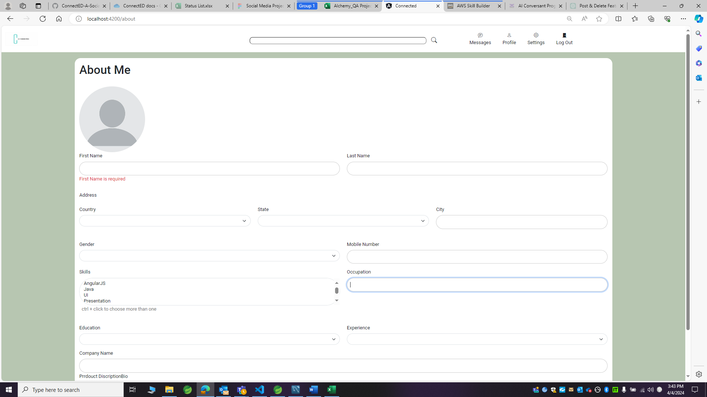

Advertiser about me page expected page:

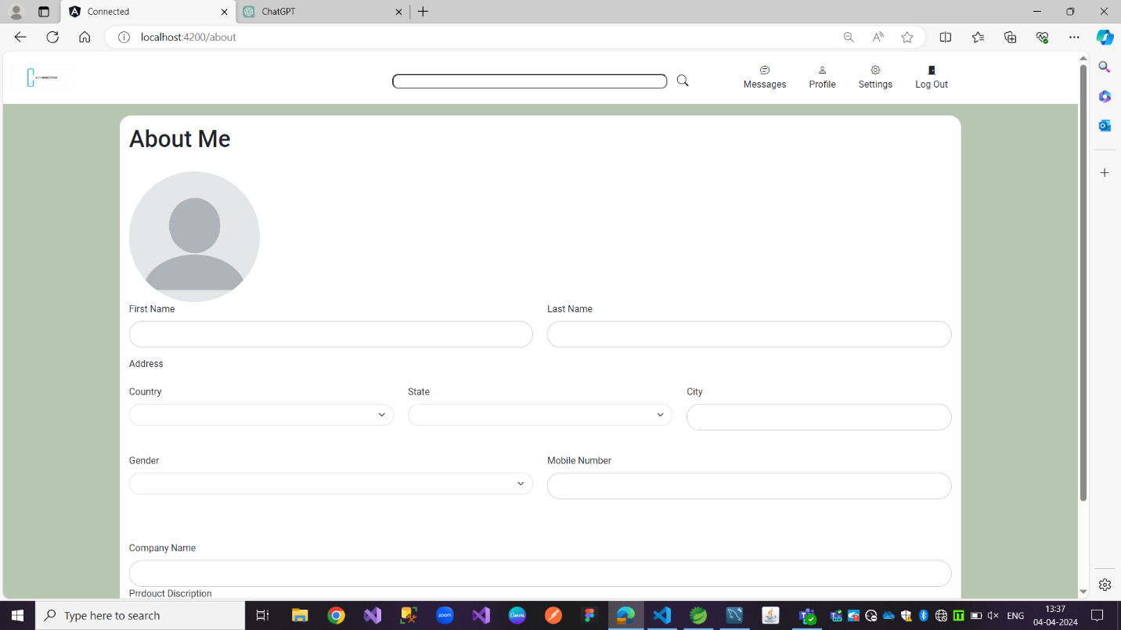

Observation 2:

Product description field title is not displaying as expected.

Advertiser about me page:

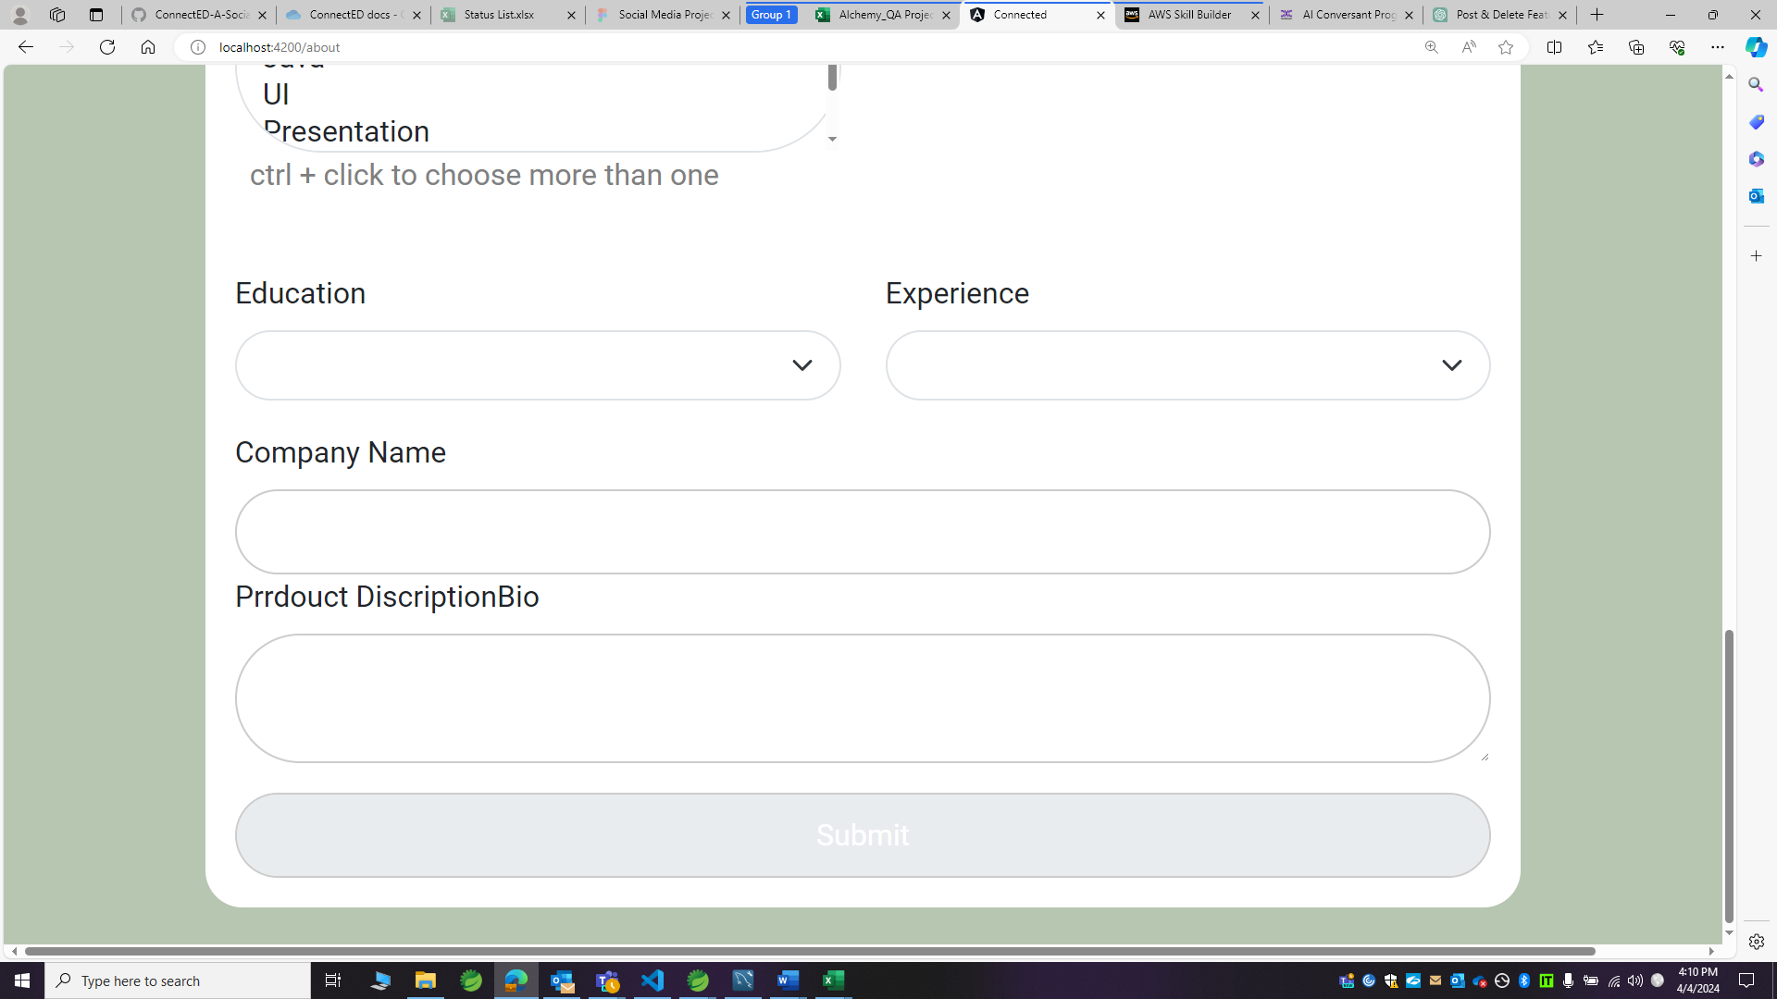

Advertiser about me page expected page:

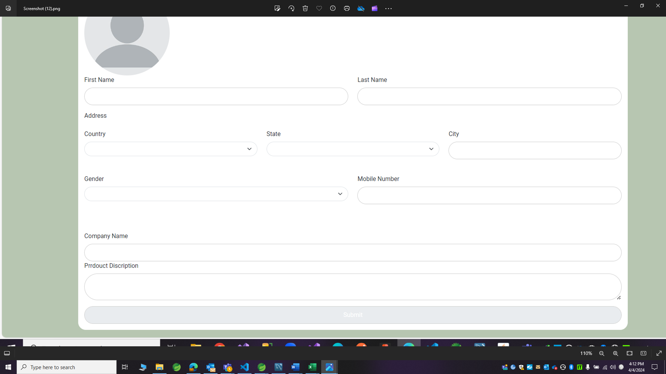

Observation 3:

Under the skills field its allowing to select multiple skills by dragging the cursor rather it should allow to select multiple skills based on ctrl + click.

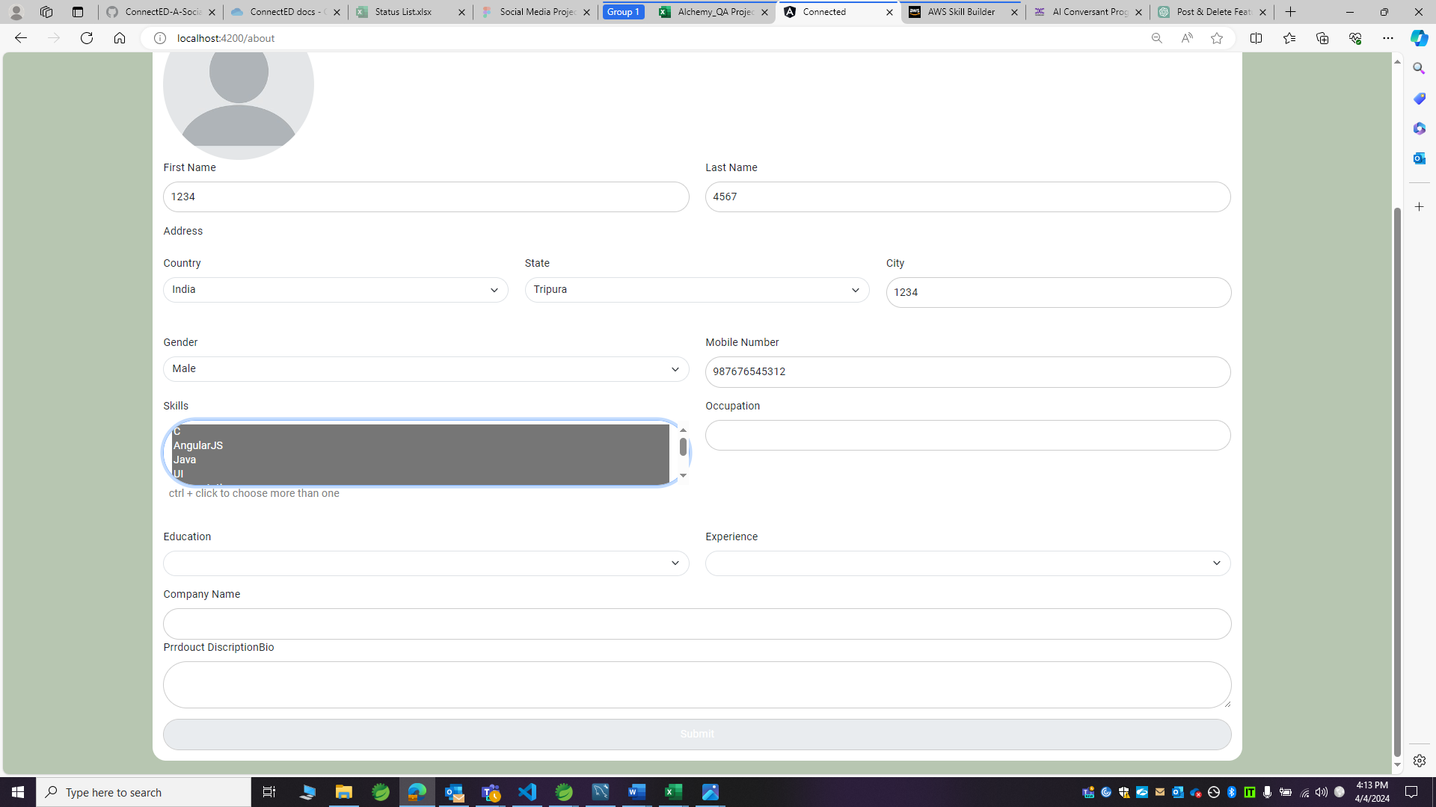

Observation 4:

Error message is not displaying when more than 10 digits are entered in mobile number field.

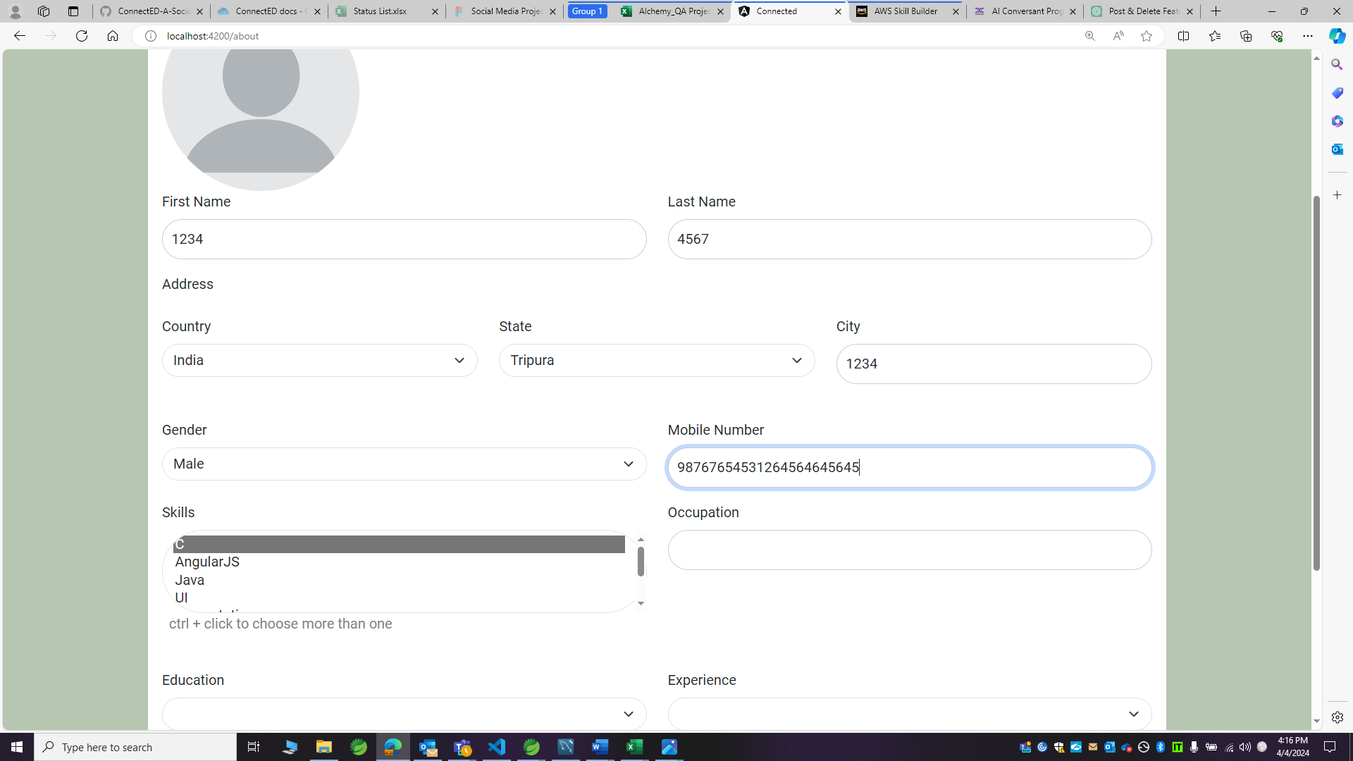

Observation 5:

First name, last name and city fields are accepting digits, but they should not.

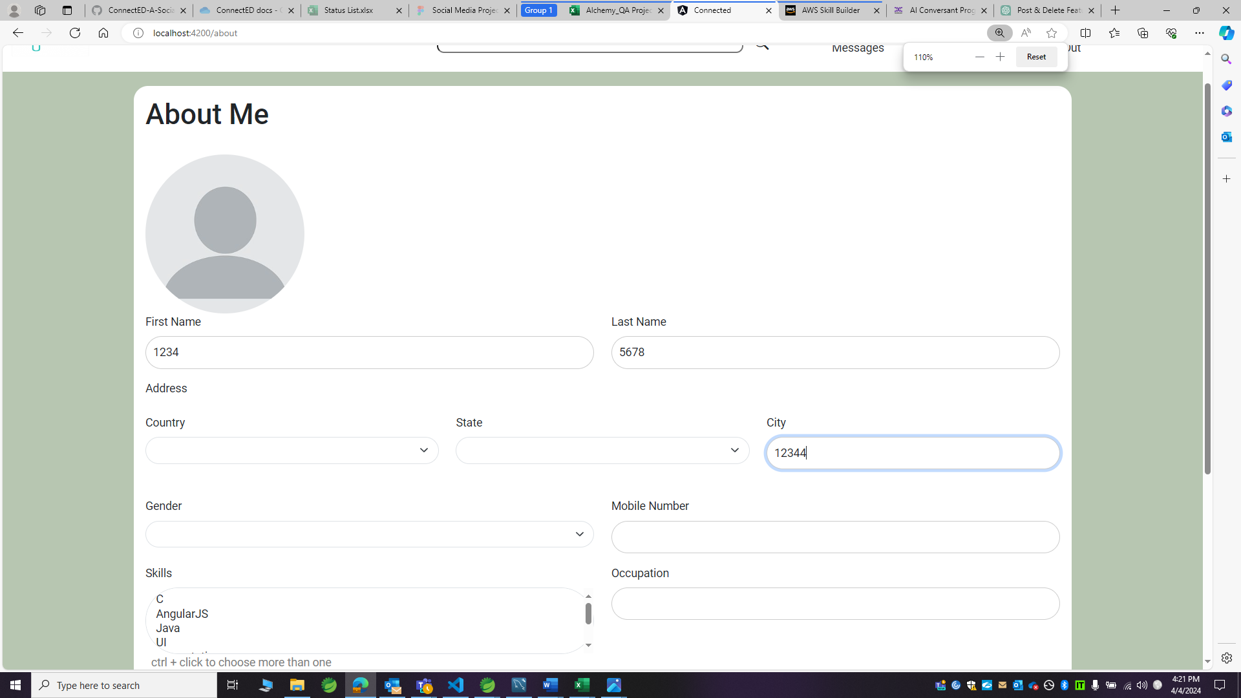

Observation 6:

After filling all details except skills and profile photo, submit button is still getting enabled, but it should not, but user is not able to submit the form unless he fills all details including profile photo.

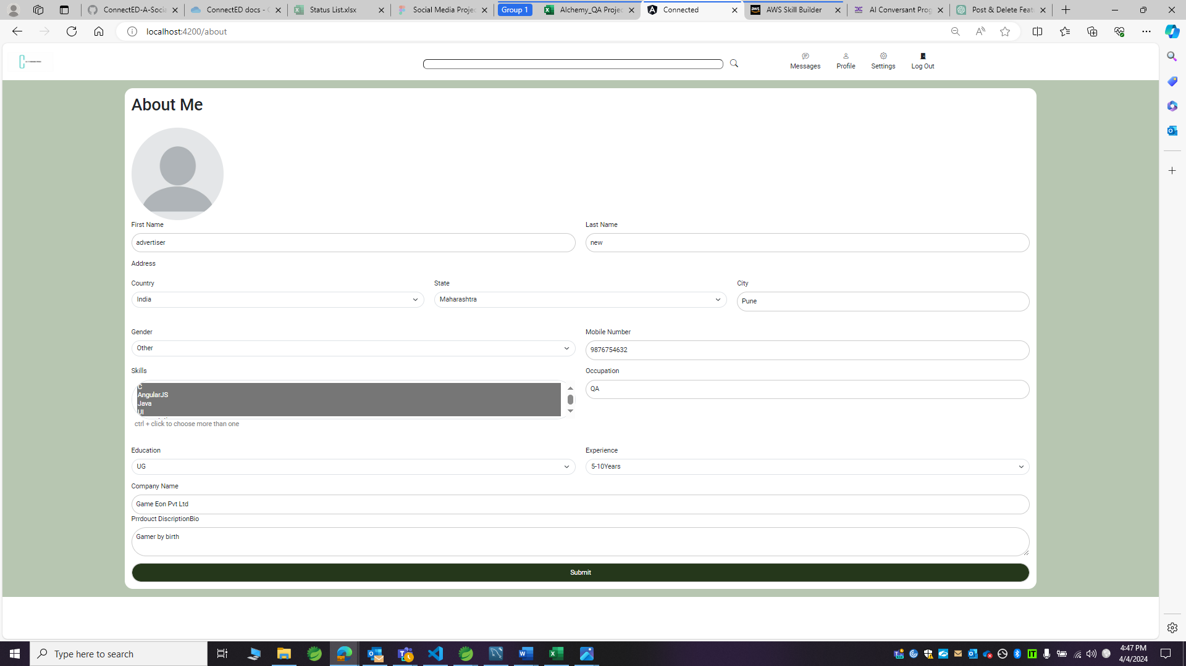

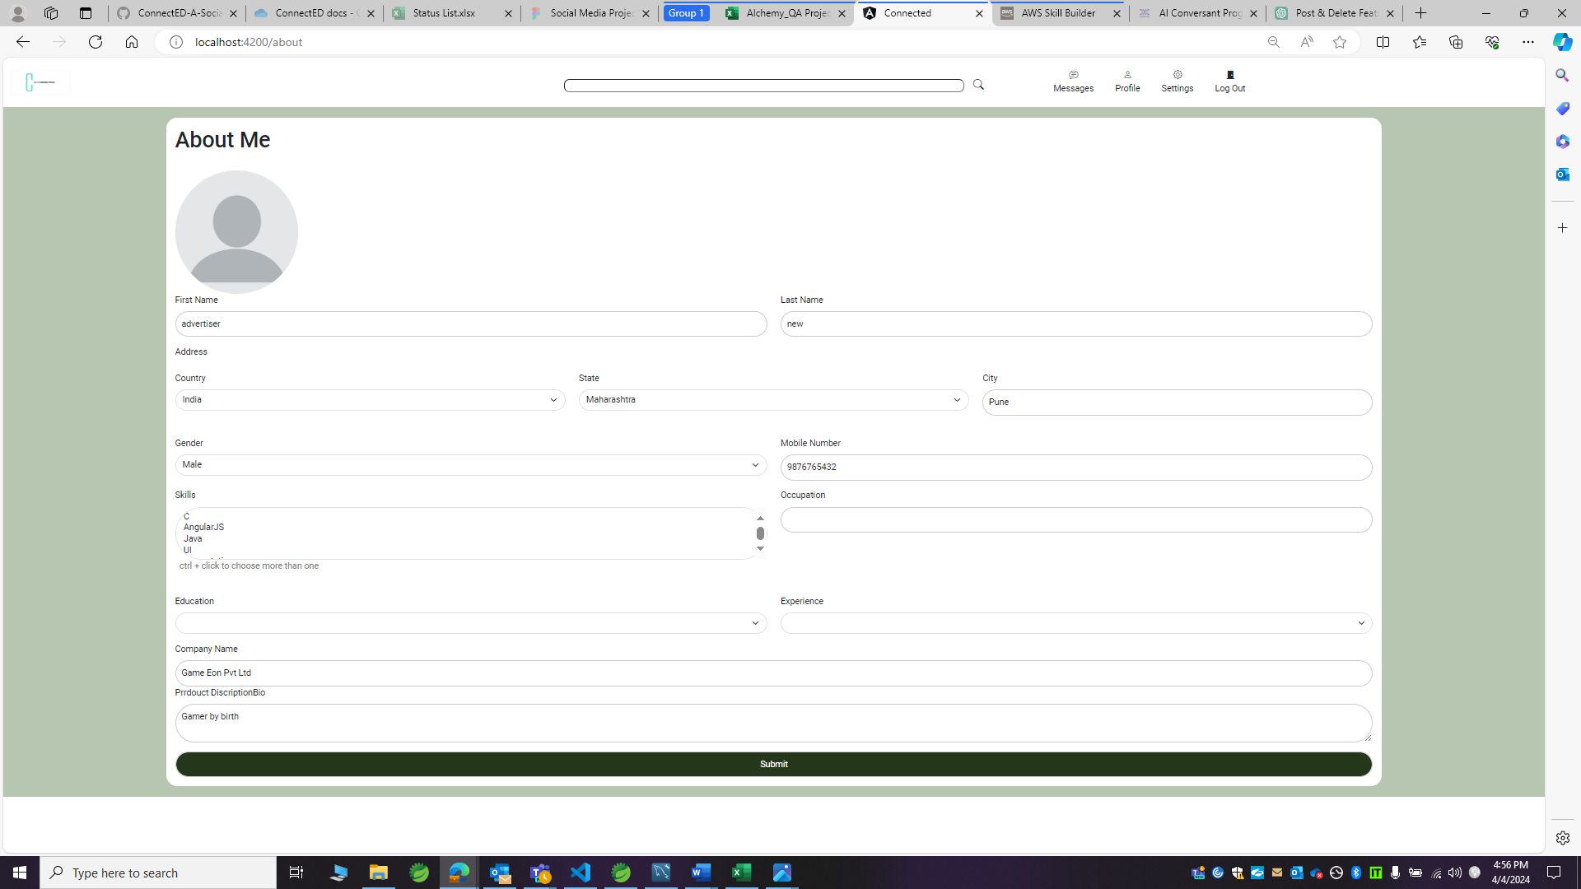

Observation 6:

Either country field should be pre-filled and non-editable or in dropdown multiple countries should be there.

State dropdown should not be visible, or user should not be able select it until country is selected.

